SUMMER PROGRAM 2016

July, August & September

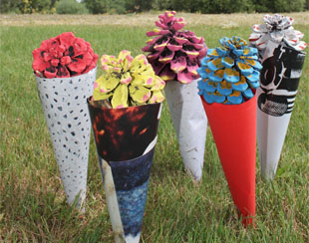
FULL MOON LIGHT AT THE NMAC COLLECTION
July 20th, August 18th & September 16th
GUIDED VISITS TO THE LIGHT SEQUENCE BY JAMES TURRELL
Every sunset (Monday closed)
Saturday special price. Friday children´s day
TURRELL, THE LIGHT´S MAGICIAN
Optical Illusion wokshop and special guided tour to The Liht Sequence for children under 12 and families.
ART SCAVENGER HUNTS FOR FAMILIES AND GROUPS
Every Sunday from 11 to 14 h
CHILDREN WORKSHOPS OF LAND ART & RECYCLING
Thursday, July 7th & 14th: “ICE CREAM LANDSCAPE”
Thursday, July 21st & 28th: “ALL THIS WAS INVISIBLE”
Thursday, August 4th & 11th: “SEWING THE EARTH”
Thursday, August 25th: “R QUE R” by Arsenio Rodríguez
THEATRE, DANCE AND MUSIC
Friday, July 29th: CLOWN “That is love”
Friday, August 12th: Contemporary Dance among Sculptures. “MAGNETIZED”
Saturday, September 17th: Darrell Mayers Concert at “Second Wind 2005”

JULY
TUESDAY | WEDNESDAY | THURSDAY | FRIDAY | SATURDAY |  | SUNDAY
 |  |  | 1  “TURRELL, THE LIGHT´S MAGICIAN” | 2  GUIDED TOUR TO THE LIGHT SEQUENCE |  | 3  SCAVENGER  HUNT FOR FAMILIES AND GROUPS
5  VISIT TO  NMAC collection | 6  VISIT TO  NMAC collection | 7  WORKSHOP FOR CHILDREN:  “Ice-Cream Landscape” | 8  “TURRELL, THE LIGHT´S MAGICIAN” | 9  GUIDED TOUR TO THE LIGHT SEQUENCE | 10  SCAVENGER  HUNT FOR FAMILIES AND GROUPS
12  VISIT TO  NMAC collection | 13  VISIT TO  NMAC collection | 14  WORKSHOP FOR CHILDREN  “Ice-Cream Landscape” | 15  “TURRELL, THE LIGHT´S MAGICIAN” | 16  GUIDED TOUR TO THE LIGHT SEQUENCE | 17  SCAVENGER  HUNT FOR FAMILIES AND GROUPS
19  VISIT TO  NMAC collection | 20  “FULL MOON LIGHT AT THE NMAC COLLECTION” | 21  WORKSHOPS FOR CHILDREN  “All this was invisible” | 22  “TURRELL, THE LIGHT´S MAGICIAN” | 23  GUIDED TOUR TO THE LIGHT SEQUENCE | 24  SCAVENGER  HUNT FOR FAMILIES AND GROUPS
26  VISIT TO  NMAC collection | 27  VISIT TO  NMAC collection | 28  WORKSHOP FOR CHILDREN  “All this was invisible” | 29  CLOWN SHOW  “That is love” | 30  GUIDED TOUR TO THE LIGHT SEQUENCE | 31  SCAVENGER  HUNT FOR FAMILIES AND GROUPS

NEWS

Ice - cream Landscape  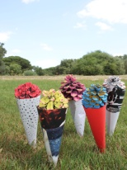 | All this was invisible  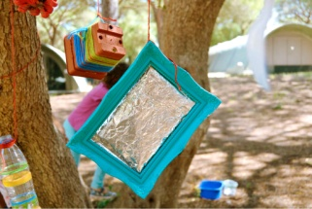 | That is love  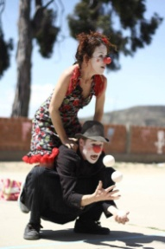

“FULL MOON LIGHT AT THE NMAC COLLECTION”

Wednesday July 20th. 21.30h

On July 20th, visitors will have the unique opportunity of seeing the NMAC collection and its forest under the full moon with the activity "Full moon light at The NMAC Collection”. The public will be guided through the sculpture park, where they will see the works from a different perspective with the help of the torches.

Booking is required. 50% of payment will be paid in advance
Check the timetable and request more information at reservas@fundacionnmac.org
Children with adults company is required
Price: Adults 12€ / Student 8€ / Children 6€

“TURRELL, THE LIGHT´S MAGICIAN”
Every Friday at sunset in July, excluding July 29th

Every Friday at sunset, children and parents will visit the light sequence in Second Wind. During this special visit will discover the mechanism of our perception and surprising optical effects with the new workshop “Turrell, the Light´s magician”.

Booking is required. 50% of payment will be paid in advance
Check the timetable and request more information at reservas@fundacionnmac.org
Children with adults company is required

Adults price: 30 €
Children price: 10 €

GUIDED TOUR TO THE LIGHT SEQUENCE BY JAMES TURRELL
Every sunset. Monday is closed. Saturday special price

NMAC Foundation opens the guided visits to the light sequence of work “Second Wind 2005” by James Turrell.
The visits will take place from Tuesday to Sunday upon previous reservation. Once again the public will be able to perceive the spectrum of Turrell’s colours looking at the sky from the magical Stupa. Do not wait any longer to make your reservation.

Not recommended for Children under 12 years old
Booking is required. 50% of payment will be paid in advance
Duration of 45 minutes. Check the timetable and request more information at reservas@fundacionnmac.org
Limited seating above 30
Prices: Saturday: 15 € . Tuesday, Wednesday, Thursday, Friday and Sunday: 30 €

ART SCAVENGER HUNTS TO FAMILIES AND GROUPS

Every Sunday in August from 11.00 am to 14.00 pm

The NMAC Foundation has programmed a Scavenger hunts for families and groups all Sundays of the month of July, where participants will become real explores around the most hidden corners of the forest of NMAC Foundation.
Booking is required. 50% of payment will be paid in advance
Price: 5 €

Timetable: From 11.00 am to 14.00 pm

CHILDREN WORKSHOPS OF LAND ART & RECYCLING
Every Thursday in July at 18.30 pm

The NMAC Foundation team has designed new and fresh workshops for this season inspired in Land art Current and made of every day and natural objects such as pinecones and recycled objects.
Thursday, July 7th & 14th: “ICE CREAM LANDSCAPE”
Thursday, July 21th & 28th: “ALL THIS WAS INVISIBLE”
Booking is required. 50% of payment will be paid in advance
Ages: Ice Cream Landscape: 4-12 years old / All this was invisible: 6-12 years old
Price: 5 €

Timetable: At 18.30 pm

CLOWN SHOW “That is love”
July 29th. From 19.00 to 10.40 pm

One of the surprises of this season is this special Clown Show undertaken by Myrtille and Benoit Vivien. Clowning around love, a mixture of acrobatics, dance and juggling.
Booking is required. 50% of payment will be paid in advance
The show will be possible with a minimum of public
Families and children over 3 years old
Price: Adult 10 €/ Children 5 €

Timetable: from 19.00 to 19.40 pm

AUGUST

TUESDAY | WEDNESDAY | THURSDAY | FRIDAY | SATURDAY | SUNDAY
2  VISIT TO  NMAC collection | 3  VISIT TO  NMAC collection | 4  WORKSHOP FOR CHILDREN  “Sewing the earth” | 5  “TURRELL, THE LIGHT´S MAGICIAN” | 6  GUIDED TOUR TO THE LIGHT SEQUENCE | 7  SCAVENGER  HUNT FOR FAMILIES AND GROUPS
9  VISIT TO  NMAC collection | 10  VISIT TO  NMAC collection | 11  WORKSHOP FOR CHILDREN  “Sewing the earth” | 12  CONTEMPORARY DANCE “MAGNETIZED” | 13  GUIDED TOUR TO THE LIGHT SEQUENCE | 14  SCAVENGER  HUNT FOR FAMILIES AND GROUPS
16  VISIT TO  NMAC collection | 17  VISIT TO  NMAC collection | 18  “FULL MOON LIGHT AT THE NMAC COLLECTION” | 19  “TURRELL, THE LIGHT´S MAGICIAN” | 20  GUIDED TOUR TO THE LIGHT SEQUENCE | 21  SCAVENGER  HUNT FOR FAMILIES AND GROUPS
23  VISIT TO  NMAC collection | 24  VISIT TO  NMAC collection | 25  WORKSHOP FOR CHILDREN  “R que R” | 26  “TURRELL, THE LIGHT´S MAGICIAN” | 27  GUIDED TOUR TO THE LIGHT SEQUENCE | 28  SCAVENGER  HUNT FOR FAMILIES AND GROUPS
30  VISIT TO  NMAC collection | 31  VISIT TO  NMAC collection

NEWS

“SEWING THE EARTH” | “R QUE R”  RECYCLING  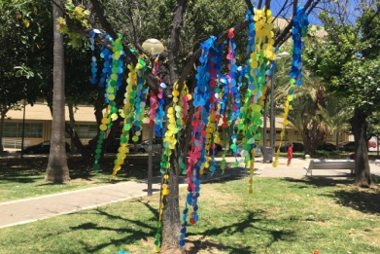 | MAGNETIZED  DANCE  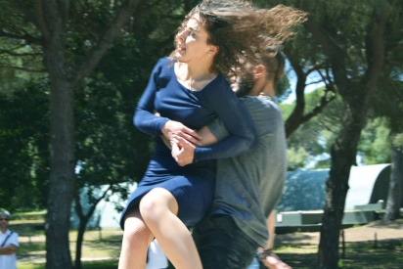

“FULL MOON LIGHT AT THE NMAC COLLECTION”

Thursday August 18th at 21 pm

On August 18th, visitors will have the unique opportunity of seeing the NMAC collection and its forest under the full moon with the activity "Full moon light at The NMAC collection”. The public will be guided through the sculpture park, where they will see the works from a different perspective with the help of the torches.

Booking is required. 50% of payment will be paid in advance
Check the calendar and request more information at reservas@fundacionnmac.org
Children with adults company is required
Price: Adults 12€ / Student 8€ / Children 6€
Timetable: at 21 pm

GUIDED TOUR TO THE LIGHT SEQUENCE BY JAMES TURRELL
Every sunset. Monday is closed. Saturday special price

NMAC Foundation opens the guided visits to the light sequence of work “Second Wind 2005” by James Turrell.
The visits will take place from Tuesday to Sunday upon previous reservation. Once again the public will be able to perceive the spectrum of Turrell’s colours looking at the sky from the magical Stupa. Do not wait any longer to make your reservation.

Not recommended for Children under 12 years old
Booking is required. 50% of payment will be paid in advance
Duration of 45 minutes. Check the timetable and request more information at reservas@fundacionnmac.org
Limited seating above 30
Prices: Saturday: 15 € . Tuesday, Wednesday, Thursday, Friday and Sunday: 30 €

“TURRELL. THE LIGHT´S MAGICIAN”
Every Friday in August at sunset

Every Friday, children and parents will visit the light sequence in Second Wind. During this special visit will discover the mechanism of our perception and surprising optical effects with the new workshop “Turrell, the Light´s magician”.

Booking is required. 50% of payment will be paid in advance
Check the calendar and request more information at reservas@fundacionnmac.org
Children with adults company is required

Adults price: 30 €
Children price: 10 €

ART SCAVENGER HUNTS FOR FAMILIES AND GROUPS

Every Sunday in August from 11.00 am to 14.00 pm

For families and groups the NMAC Foundation has programmed a Scavenger hunts all Sundays of the month of August, where participants will become real explores around the most hidden corners of the forest of NMAC Foundation.
Booking is required. 50% of payment will be paid in advance
Price: 5 €

Timetable: From 11.00 am to 14.00 pm

CHILDREN WORKSHOPS OF LAND ART & RECYCLING
Thursday August 4th,11th & 25th at 18.30 pm

The NMAC Foundation offers different workshops for this season inspired in Land art Current and made of wool and plastic.
Both workshops teach children to love the nature and save the environment in a creative way.
Thursday, July 4th & 11th: “SEWING THE EARTH” by NMAC team.
Thursday, July 25th: “R QUE R” by Arsenio Rodríguez
Booking is required. 50% of payment will be paid in advance
Price: “SEWING THE EARTH” 5 € /“R QUE R” 15€

Timetable: At 18.30 pm
Ages: From 7 to 14 years old

CONTEMPORARY DANCE AMONG SCULPTURES
“MAGNETIZED”
August 12th. At 19.00 pm

“MAGNETIZED” is a poject based on the attraction in the relationships during its different phases. It has been directed by Charo Cruz and interpreted by Paula Yanes and Francisco Melero.
Booking is required. 50% of payment will be paid in advance
The show will be possible with a minimum of public
Price: Adults 10 €

Timetable: from 19.00 to 19.45 pm

SEPTEMBER

TUESDAY | WEDNESDAY | THURSDAY | FRIDAY | SATURDAY | SUNDAY
 |  | 1  VISIT TO NMAC collection | 2  “TURRELL ,THE LIGHT´S MAGICIAN” | 3  GUIDED TOUR TO THE LIGHT SEQUENCE | 4  SCAVENGER  HUNT FOR FAMILIES AND GROUPS
6 | 7 | 8  VISIT TO  NMAC collection | 9  “TURRELL ,THE LIGHT´S MAGICIAN” | 10  GUIDED TOUR TO THE LIGHT SEQUENCE | 11  SCAVENGER  HUNT FOR FAMILIES AND GROUPS
13  VISIT TO  NMAC collection | 14  VISIT TO  NMAC collection | 15  VISIT TO  NMAC collection | 16  “FULL MOON LIGHT AT THE NMAC COLLECTION” | 17  “DARRELL MAYERS CONCERT AT JAMES TURRELL PROJECT” | 18  SCAVENGER  HUNT FOR FAMILIES AND GROUPS
20  VISIT TO  NMAC collection | 21  VISIT TO  NMAC collection | 22  VISIT TO  NMAC collection | 23  “TURRELL ,THE LIGHT´S MAGICIAN” | 24  VISITA GUIADA TURRELL.  PRECIO ESPECIAL | 25  SCAVENGER  HUNT FOR FAMILIES AND GROUPS
27  VISIT TO  NMAC collection | 28  VISIT TO  NMAC collection | 29  VISIT TO  NMAC collection | 30  “TURRELL ,THE LIGHT´S MAGICIAN”

NEWS

“MOTES FLOAT ALOFT” AT JAMES TURRELL PROJECT

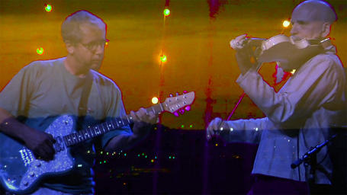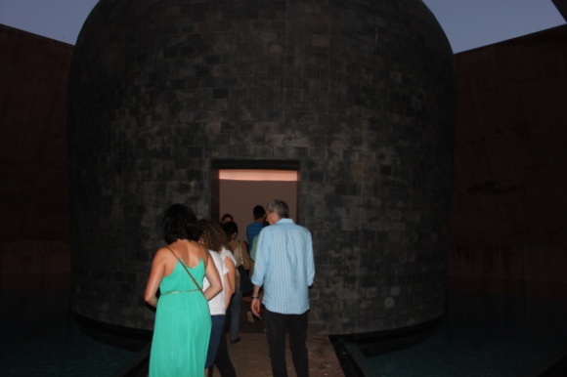

“FULL MOON LIGHT AT THE NMAC COLLECTION”

Sunday September 16th at 20.30 pm

On September 16th, visitors will have the unique opportunity of seeing the NMAC collection and its forest under the full moon with the activity "Full moon light at The NMAC Collection”. The public will be guided through the sculpture park, where they will see the works from a different perspective with the help of the torches.

Booking is required. 50% of payment will be paid in advance
Check the timetable and request more information at reservas@fundacionnmac.org
Children with adults company is required
Price: Adults 12€ / Student 8€ / Children 6€

“TURRELL. THE LIGHT´S MAGICIAN”
Every Friday in September at sunset

Every Friday, children and parents will visit the light sequence in Second Wind. During this special visit will discover the mechanism of our perception and surprising optical effects with the new workshop “Turrell, the Light´s magician”

Booking is required. 50% of payment will be paid in advance
Check the calendar and request more information at reservas@fundacionnmac.org
Children with adults company is required

Adults price: 30 €
Children price: 10 €

GUIDED TOUR TO THE LIGHT SEQUENCE BY JAMES TURRELL
Every sunset. Monday is closed
Saturday special price

NMAC Foundation opens the guided visits to the light sequence of work “Second Wind 2005” by James Turrell.
The visits will take place from Tuesday to Sunday upon previous reservation. Once again the public will be able to perceive the spectrum of Turrell’s colours looking at the sky from the magical Stupa. Do not wait any longer to make your reservation.

Not recommended for Children under 12 years old
Booking is required. 50% of payment will be paid in advance
Duration of 45 minutes. Check the timetable and request more information at reservas@fundacionnmac.org
Limited seating above 30
Prices: Saturday: 15 € . Tuesday, Wednesday, Thursday, Friday and Sunday: 30 €

ART SCAVENGER HUNTS TO FAMILIES AND GROUPS
Every Sunday in September from 11.00 am to 14.00 pm

For families and groups the NMAC Foundation has programmed a Scavenger hunts all Sundays of the month of September, where participants will become real explores around the most hidden corners of the forest of NMAC Foundation.
Booking is required. 50% of payment will be paid in advance
Price: 5 €

CONCERT AT JAMES TURREL´S ART WORK BY NIGEL JACOBS & DARREL MAYERS
“MOTES FLOAT ALOFT”
September 17th. At 19.00 pm

“Motes Float Aloft is the musical duo of Nigel Jacobs & Darrel Mayers; both born & raised in England, they now live in Austin, Texas, where they formed the group. They create dark ambient cinematic soundtracks, using electric violins, guitars & a variety of home-made instruments to create their unique electro-acoustic sounds. In 2014 they performed at InspiroFest in Austin & completed a soundtrack for the full-length feature, Run Away Night, directed by Georgetowne Ray. In 2015 they presented a 90-minute work within artist James Turrell's, The Color Inside light sculpture & they just completed a soundtrack for the Indonesian indie film-maker Yusgunawan Marto's new movie, Law Abiding Angels. Darrel is also the music director & guitarist of the great Mundi Ensemble.
In this occasion, The duo will repeat that musical experience in one of the biggest Sky´Spaces by James Turrell in Europe at NMAC Foundation on September 17th at 19.00 pm.
Booking is required. The show will be possible with a minimum of public.
Families and children over 12 years old
Price: Donations

Timetable: from 19.00 to 19.45 pm

SUMMER ACTIVITIES

- Booking in each activity is required. To reserve, visitors will have to pay 50% in advance. More information at reservas@fundacionnmac.org or by phone + 34 956455134
- The NMAC Foundation will cancel the activities if the number or participants were not enough.

